STUDIO WEST
PRESENTS

FANCY A BITE?
A GROUP EXHIBITION OF WOMEN ARTISTS EXPLORING FOOD
15 June – 6 July 2022

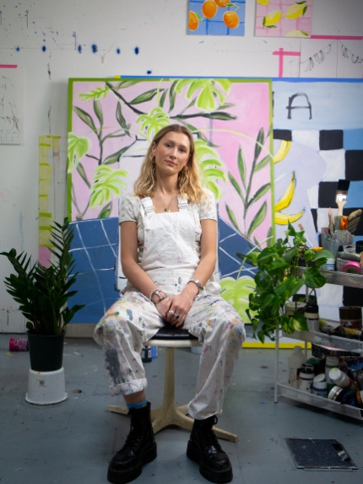
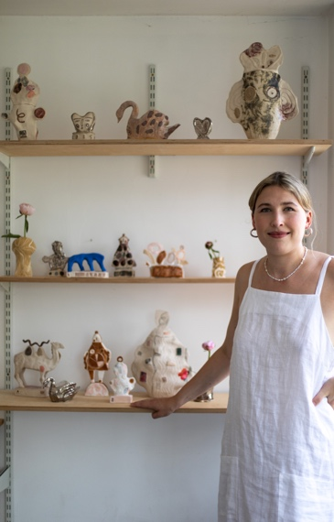
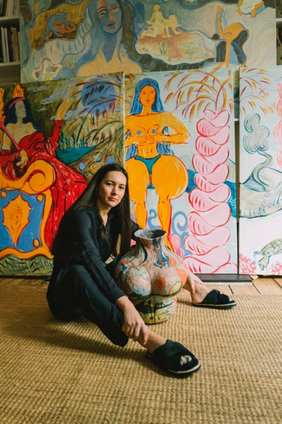

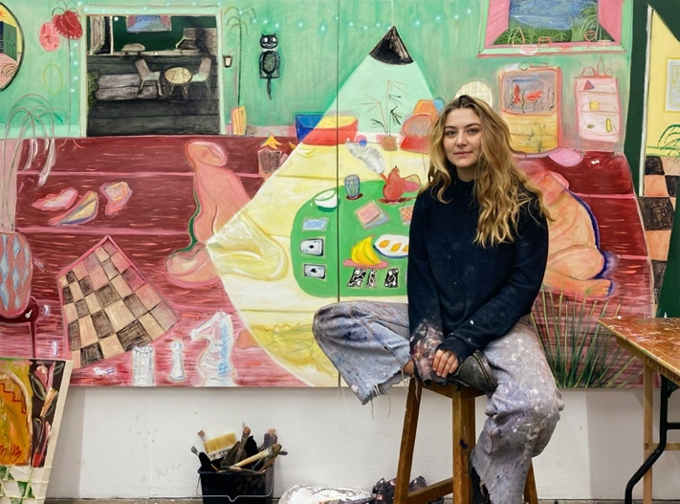
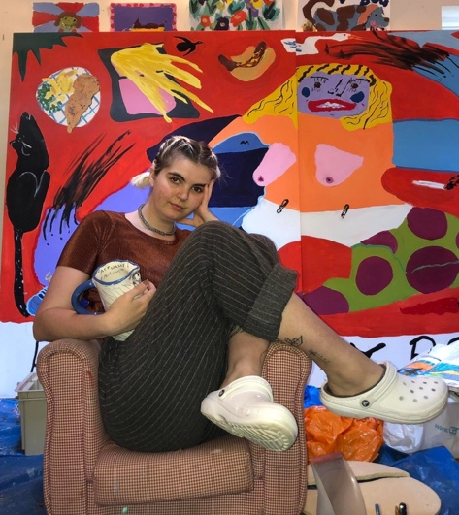

ALICE JOHNSON, PHOEBE BODDY, RAFAELA DE ASCANIO,
PIPPA EL-KADHI BROWN AND NELL MITCHELL,

STUDIO WEST is proud to present FANCY A BITE? a group exhibition showcasing the work of five women artists whose practices explore the politics of food. Themes emerge surrounding our complex relationships to food, domesticity, nostalgia, and cultural heritage. Through installation, ceramic sculpture and painting FANCY A BITE? encourages the viewer to delve into each artists’ unique relationship with food, and consider the silent politics at play in the everyday act of eating.

Throughout time and in every culture, human beings have eaten together. Commensality - eating and drinking at the same table - is a fundamental social activity, which creates and cements relationships. Meals are everyday rituals of profound importance in social life. They reinforce cultural values specific to communities, and evoke feelings of nostalgia, belonging and pleasure. The politics of gastronomy are key to understanding many social negotiations and societies. Issues of gender, race, class and culture all emerge in the wider conversation of what decisions surrounding food and eating can represent.

Therefore, it is perhaps unsurprising, that there is a prevalent history of women creating politically active artwork about and with food – examples include Carolee Schneemann’s controversial performance Meat Joy (1964) and Sarah Lucas’ iconic Self-Portrait with Fried Eggs (1996) where egg yolks stand in for nipples. Historically, food has been mobilised by women artists from championing female emancipation from domestic duties and to discussing the female body. Nowadays, in western society, women are generally liberated from exclusive domestic labour and the preparation of food is not always a gendered act. Yet, food continues to be a prevalent topic in work by women artists.

Painter and ceramicist Nell Mitchell makes work about “normal things” that “are often passed by or less noticed”. Combining a deliberately naïve style, a vibrant palette and humorously relatable subject matter, her work breeds an air of unguarded “triviality and silliness”. Mitchell’s Dinner Party installation takes a closer look at the relationship between food culture and moralising consumption, through the lens of amusing ceramic objects laden with phrases such as “You Are What You Eat!” and “A Moment on the Lips, A Lifetime on the Hips!”. Similar in tone, Phoebe Boddy’s practice takes flavour and the sensation of eating as a starting point for bold, graphic paintings. She comments, “food and flavour are my greatest influences”. Although these two artists create works that, at first, appear uncomplicated, there is something deeper at play in the act of monumentalising the everyday. Canvases and sculptures act as odes to passing moments spent with friends, pedestalling intimate exchanges over meals, generating what is often referred to as “food nostalgia”.

Sculptor Alice Johnson is known for her iconic ceramic prawns, small sculptures that straddle categories of fine art and functional craft. The little vessels are acts of metamorphosis, a prawn becomes a vase, a vase becomes an art work. They play with the notion of food as a decorative and aesthetic object, rather than as a source of sustenance. This points to wider issues surrounding class and access to certain foodstuffs. In their decorative quality, they are loosely reminiscent of the kinds of monumental feasts a King might dine on, while a peasant goes hungry. These kinds of social relations encoded in food are explored in varying manifestations subtly throughout the body of work.

Pippa El-Kadhi Brown’s fluidly painted, bright and charming work looks at the matter of the domestic environment as a space suggestive of the occupier, “filled with objects that allude a past, present and future, exposing certain elements, but more importantly, concealing others”. For El-Kadhi Brown the personal and the domestic are political. Through her paintings and sculptures, we see our homes expanded, both in terms of scale and perspective. Vibrant colour palettes mimic food-stuffs, with the familial table often centrally placed.

In Rafaela de Ascanio’s installation, consisting of painting, sculpture and ceramic, she focuses on the ritual act of feasting. Taking antiquity as a starting point, the works included in FANCY A BITE? re-evaluate the importance of meals as esoteric pagan practices, as well as gendered occasions. Inserting women into her works, they are defiant, powerful and importantly, very much in charge. De Ascanio’s work also alludes to her cultural heritage, with early years spent in the volcanic Canary Islands, bleeding into her tropical colour palettes.

The exhibition brings together contemporary woman artists making work exploring the culinary, the delicious and the domestic. Through the pieces on show, wider issues are brought to light surrounding gendered relations, class relations and cultural heritage. The act of collective dining is inherently political. Shared meals, both historically and in the present, cement relationships, encode social hierarchies and delineate boundaries surrounding class and gender, inadvertently mirroring wider society. Through a joyful yet complex display of artwork, STUDIO WEST creates a welcoming environment within which we may reflect on the role food plays in our own lives.

Alongside the exhibition, the artists have collectively created a recipe book of dishes that hold personal resonances. The recipe book is an intimate and tactile representation of the unique associations each artist has with food and nourishment. The exhibition coincides with Kensington + Chelsea Art Week 2022, themed ‘Nourish’, forming part of a wider celebration of enrichment for the mind, body and soul across the borough. Special events will take place over the course of the show, including a Yoga Class on Sunday 19 July, collecting dry goods for the Kensington and Chelsea Food Bank, a Panel Discussion featuring a range of experts in the field, including Michelin trained local chef Louis Ashok on Thursday 28 June, and a Tea Party at the gallery on Saturday 2 July, inviting visitors to enjoy the exhibition and share food and drink together.

ABOUT NELL MITCHELL
Nell Mitchell (b. 1998) is a multi-disciplinary artist based in East London, whose diary-like and confessional practice uses humour in which to convey very real emotions. Graduating from The Glasgow School of Art in 2020, Nell aims to create work that is both relatable and deeply personal by viewing each individual piece of work as a window to the soul, with no holds barred. She finds that using light-heartedness in her paintings allows her to convey herself completely through a piece of work - Nell continues to build and grow alongside her practise, as something that above all else aims to brings the artist and its audience joy. Ultimately, Mitchell’s goal is to create simple and relatable work that speaks for itself (sometimes quite literally!), with the hope that it can provide comfort, solace, and laughter to a wide variety of people. Recently, Nell has exhibited work in ‘Laugh-able’, an exhibition run by adam&eveDDB in collaboration with Fresh Takes and She Takes Over – designed to combat the idea that women are not funny. Nell has recently been selected to exhibit work in Liliya Gallery’s most recent open call, exhibited her work alongside fellow Glasgow School of Art graduates in On The Other Side - an exhibition curated by Aeji Seo at Hoxton 253, in Big Pleasures’ and ‘Small Pleasures, two online auctions by All Mouth Gallery, and has had her work sold with online auction site AucArt. Her work has been featured by The Times and It’s Nice That.

ABOUT PHOEBE BODDY
Phoebe Boddy graduated a BA in Fine Arts at Loughborough University in 2017 and currently lives and work in London. Recent exhibitions include Collection One (2021) and Collection Two (2022) at Katherine Richards Art Gallery in Brighton, Palette 04 (2021) at The Old Bank Vault in London, One For The Road (2021) at The Koppel Project in London and Figurative Art Now (2021) at Mall Galleries in London. She co-founded Palette (@palettedining), a concept hosting unique dining experiences exploring the sensory connections between Food & Art. She has been featured by Absolutely Magazine, FAD Magazine, and SheerLuxe.

ABOUT PIPPA EL-KADHI-BROWN
Having graduated a BA from the University of Brighton in 2018, Pippa El-Kaghi-Brown is currently finishing a Masters from the Royal College of Art. Her solo exhibitions include Where the Dust Settles (2022), CBU Gallery in Taipei, Around You, Within You, or Nowhere at All at Ashurst (2020) in London and House Plants (2019), Creekside Projects in London. She has exhibited in multiple group exhibitions, many of which in Asia, including at One Art Taipei (2022), The Sherwood Taipei, Garden of the New Deity (2022), Lí Gallery in Shanghai, and Star Start 2 (2021), Rear Window Gallery in Hangzhou, China. She has been awarded the Ashurst Emerging Artist Prize 2020, The Ali H. Alkazzi Scholarship Award 2020 by the Royal College of Art, the Art Pegazs Taste of Life Award 2019 and Creekside Artists Graduate Studio Award 2019. She has completed residencies in London, Latvia and China. She has been featured by Made in Bed, Where’s The Frame and She Curates.

ABOUT RAFAELA DE ASCANIO
Rafaela de Ascanio (b.1986) lives and works in London. She completed her Fine Art Foundation at Central St Martins in 2006, then went on to study at The Courtauld Institute of Art, completing her MA in 2010. In 2019 Rafaela attended the Turps Banana Painting Programme. Recent solo exhibitions include Universal Yearnings (2021), Liliya Art Gallery in London. Duo shows include Back to Back (2021) at Bowes Parris Gallery in London, The Deccan Traps (2019) at Aindrea Contemporary in London, and The Body is a Blessed Juicy Fruit (2018) at Lamb in London. Recent group shows include Cracked (2021) at Tristan Hoare in London, Focus on the Female (2021) at Cynthia Corbett Gallery in London, Monster/Beauty: An Exploration of the Female/Femme Gaze (2020) at Lychee One in London, and Paintings On, And With Paper (2020) at Cob Gallery in London. In 2021 Rafaela received the Young Masters Emerging Artist Award. She has been featured by Elephant Magazine, The Wick, FAD Magazine and Ceramics Now.

ABOUT ALICE JOHNSON
Alice Johnson completed an MA in Ceramics and Glass at the Royal College of Art in 2020 after a BA in Illustration at the University of Brighton. Exhibitions include The Power of Material: From Virtual to Physical (2021), RCA Show at the Design Museum in London, at The Amber Room (2019) in London and Otomys Gallery (2019) in Melbourne. She has been featured in House and Garden Magazine and It's Nice That. She has hosted workshops at Camden Art Centre.

PRESS ENQUIRIES | IMAGES
Bella Bonner-Evans
Lisa Baker Associates Ltd
Email: bella@lisabakerltd.com
Tel +44 (0)7508 057344
EXHIBITION INFORMATION
FANCY A BITE?
15 June – 6 July 2022
Nell Mitchell | Phoebe Boddy | Pippa El-Kadhi Brown|
Rafaela de Ascanio | Alice Johnson

SPECIAL EVENTS
Yoga Class | Sunday 19 July | 11am – 12.15pm
Panel Discussion London | Thursday 28 June | 6.30 – 8.30pm
Tea Party | Saturday 2 July | 2 – 5 pm

STUDIO WEST
Unit 1, 216 Kensington Park Road, London, W11 1NR
Nearest Tube: Ladbroke Grove / Notting Hill Gate
@studio_west_gallery | www.studiowest.art

ABOUT STUDIO WEST
STUDIO WEST is a cultural hotspot in Notting Hill founded by curator Caroline Boseley. The gallery focuses on showing work by emergent and newly established London based artists, offering support, mentorship and hosting opportunities that showcase the most exciting upcoming talents. The gallery takes a new approach to commercial, contemporary art – it puts artists' needs at the forefront and nurtures an awareness of the local community within which it operates.

STUDIO WEST opened in November 2021 with a show by Victoria Cantons and Xu Yang and has since hosted a group exhibition of five emerging London-based artists The Reality in Whytch You Create, a solo show of new pieces by Karolina Albricht titled 16 Branches High, and a duo exhibition with paintings by Anthony Laurencin and sculptures by Roland Lawar titled As Seen By Me. It is becoming known for exceptional one-off events, such as the recent ballet performance collaboration with Portobello Dance School. @studio_west_gallery | studiowest.art

During the duration of the exhibition, STUDIO WEST will be collecting dry goods which will be donated to the Kensington & Chelsea Foodbank on Lancaster Road, W11.

